

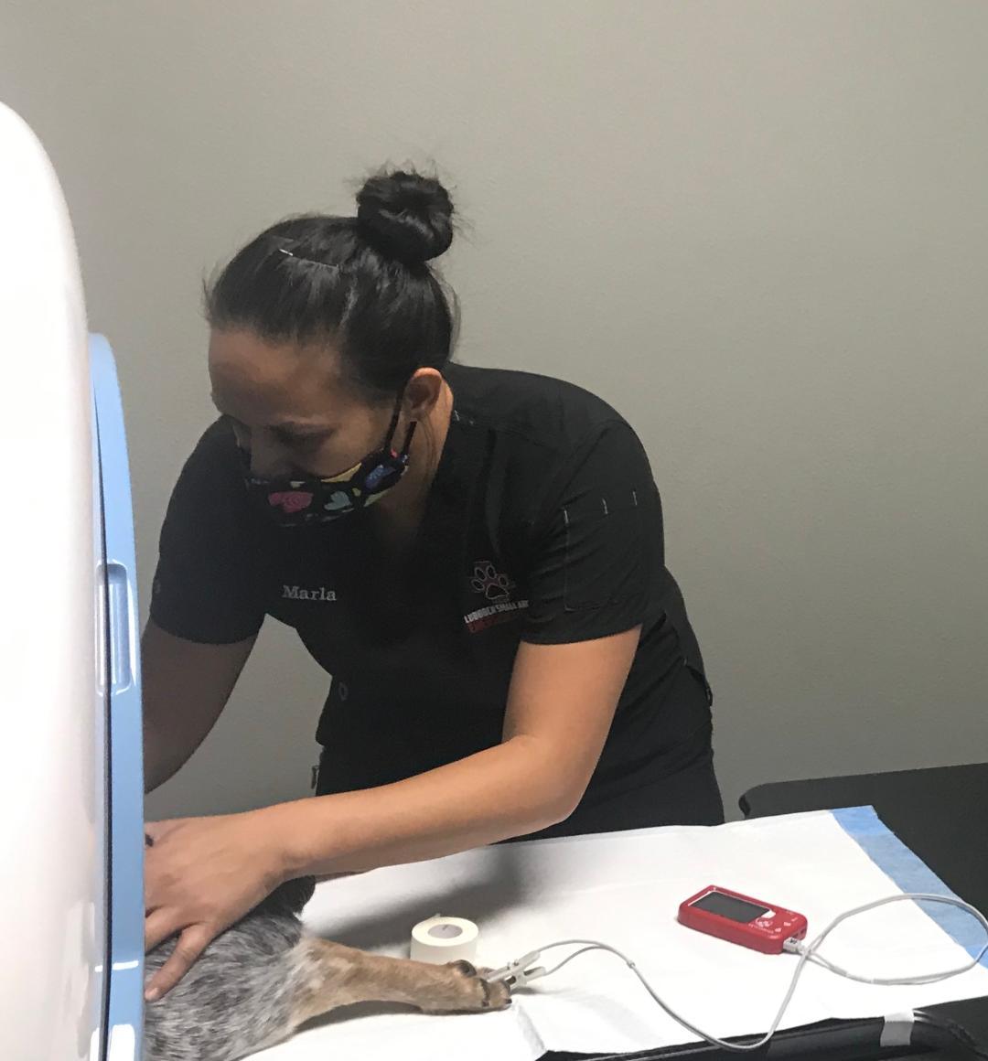



**We would be happy to serve your clients during daytime hours!**

**\*The radiologist report gets e-mailed directly to you!**

Two ways to refer:

1. Text Dr. Powe: 806-752-0999
2. Call and leave a message at the clinic: 806-797-6483
3. E-mail a CT referral sheet to info@lubbockemergencyvets.com

**For immediate assistance call Dr. Powe



**Prices:**

**All prices include anesthesia, IV catheter, cardiopulmonary monitoring, and radiologist report  **1. Dental/skull/sinuses: $350**

**2. CT one region: $500**

**3. CT two regions: $600**

**4. CT with contrast: (Myelograms)**

**<20 lbs = $650**

**20-40 lbs = $750**

**>40 lbs = $850**

CT SCAN PRICING AND REFERRAL

